|  |  |
| --- | --- |
|  | Office of the National Coordinator for Health IT  Federal Health Architecture  Program Management Office |
|  |  |
| FHA Federal Health Information Model  (FHIM)  Terminology Modeling Process | |
|  | Version 1.0  9/1/14 |

Contents

TOC \o 2-2 \t "Heading 1 A, 3,Heading 21, 4,Title2, 5"

1. Background PAGEREF _Toc \h 3
2. The FHIM and Terminology Modeling PAGEREF _Toc1 \h 3
3. Process Objectives PAGEREF _Toc2 \h 4

Clarify and Confirm Model Semantics PAGEREF _Toc3 \h 4

Provide values for use in FHIM-supported interactions PAGEREF _Toc4 \h 4

Maximize use of standards PAGEREF _Toc5 \h 5

Define value set properties PAGEREF _Toc6 \h 5

1. The FHIM Terminology Modeling Process PAGEREF _Toc7 \h 6

High-Level Process Description/Steps PAGEREF _Toc8 \h 6

Detailed Process Description PAGEREF _Toc9 \h 7

Publication PAGEREF _Toc10 \h 10

Consumption PAGEREF _Toc11 \h 13

1. Appendix A: Terminology Policies PAGEREF _Toc12 \h 15
2. Appendix B: Value Set Data Elements PAGEREF _Toc13 \h 17
3. Background

This document describes the process of developing terminologies to support the Federal Health Information Model (FHIM). The FHIM, described at FHIMS.org, is a model of health information designed to support the development of interface specifications that allow communication among federal agencies and their partners. It presents a conceptual model of health information—i.e., not specific to any single technology or platform—but it also includes features that support the generation of technology-specific, implementable specifications.

1. The FHIM and Terminology Modeling

The FHIM specifies data types for each element it contains. If an element is a “coded” type, then it is incumbent on the FHIM to specify the set of values that are valid for use in that element—states of the union in an address form, for instance, or race categories for demographics. Where possible, these values are chosen from standard terminologies in order to ensure the widest possible population can understand the terms—whether because they are already known or because the standards are publicly available for reference. Standard terminologies are a necessary foundation for comparable and interoperable data, which are key requirements for today’s increasingly integrated federal health information environments.

The role of the Terminology Modeling (TM) project is to support the FHIM modeling effort by defining terminologies to support enumerated concepts in the FHIM, whether by identifying existing terminologies, modifying existing terminologies, or developing new terminologies. The information and terminology modeling efforts will collaborate closely, and their coordination requires agile and flexible processes.

In its supporting role, FHIM terminology modeling activities also serve as a forum for the harmonization of terminology requirements among a diverse FHA partner community. After federal health organization requirements are collected and interpreted, they are published to federal participants and standards development organizations. The organizations provide feedback, including terminology content clarifications, to the terminology modeling process. This process often requires adjustments to the semantics of the element, and can cause structural changes to the information model. This is why it is critical to conduct information and terminology modeling in concert.

The TM project will also provide a specific avenue for coordination with standards development organizations (SDOs). When needs are identified that are not met by existing standards, the TM team will present these needs to the appropriate SDO for resolution.

1. Process Objectives

Clarify and Confirm Model Semantics

For each coded property, a value set is needed that meets the requirements of the federal agencies and their partners. There is often ready consensus on the values that are needed. There are also many cases where consensus is harder to reach, for a variety of reasons

1. Fields are sometimes defined imprecisely, whether because their use has been imprecise or because the users rely on tacit knowledge.
2. Different agencies may have different understandings of the requirement. This may mean there are actually two requirements, or one more general requirement may subsume the other.
3. Agencies may need different levels of granularity in their concept codes, in which case the FHIM will represent the superset of both needs.
4. Sometimes, divergent understandings of a requirement result from a need that is specific to one agency. In these cases, because the FHIM is an interoperability specification, elements that are needed by only a single agency are removed from the model. Elements that are needed for interoperability but might be mistaken for an internal element are annotated to avoid confusion.

Provide values for use in FHIM-supported interactions

Once semantic values are identified, the team attempts to find an existing value set that provides these values, or a code system from which such a value set could be constructed. Failing that, values are proposed to the appropriate code system steward.

Maximize use of standards

As noted above, it is incumbent on the team to use existing standards where possible. The team begins its search with the value sets and code systems specified in the HITSP Clinical Document and Message Terminology (C-80, available at hitsp.org). If a system is deemed appropriate but lack values, the team may engage the system steward to add missing values. If this process requires more time than is convenient, the team may also adopt a non-standard value set in the interim.

Define value set properties

In addition to the values themselves, the team must document information about the value set, including human-readable and sometimes machine-readable definitions of the set, examples and usage notes, licensing caveats, provenance (source system, possibly value sets considered for use), and publication information (stewardship, dates, status). A list of these elements is provided in Appendix B.

Finally, the team also needs to specify facts germane to how the data element is associated, or “bound” to the value set.

Binding properties:

1. Whether a binding is static or dynamic – Dynamic binding means that when the value set membership changes, such as when updated due to a code system version change, the value set used in the model reflects that change. Static means the model only uses the value set as originally defined, and it cannot change.
2. Whether a binding allows exceptions – whether codes other than those included in the value set may be used
3. Whether an element is nullable – whether an empty value is acceptable
4. Appropriate null values – whether, if empty, a value can still communicate “flavors” of null (“other,” “not applicable,” etc.)
5. Whether a coded element might support, in addition to the standard label or designation, some other textual representation (e.g., “original text” or “displayed text”)
6. The FHIM Terminology Modeling Process

High-Level Process Description/Steps

1. The IM Project leader determines the information domains to be modeled. As an information domain is modeled by the IM Project, one or more of the Terminology Modeling Sub-Project co-leads will participate in the initial discussions to provide terminology guidance/input. The Terminology Modeling co-leads will participate in subsequent calls as needed.
2. As the information domain modeling effort identifies information concepts that need to be coded, the Terminology Modeling (TM) co-leads will review and discuss each information concept and one or more of the co-leads will perform a high-level analysis to identify at least one appropriate terminology to support the information concept and identify any related work that has been accomplished by a Federal partner or an SDO.
3. If value set definition work is required, the TM co-leads will identify a co-lead to oversee/manage the work and assign the work to a terminology modeler to perform.
4. The TM co-lead overseeing/managing the value set definition work will provide the modeler leading the value set definition work with the results of the high-level analysis and will answer any questions and assist the lead with resolving any issues encountered.
5. The value set definition lead will accomplish their work through an existing vocabulary SDO (e.g., IHTSDO) whenever possible.
6. Once the analysis by the value set definition lead is completed, the lead will send an invitation to all IM Project members and TM co-leads for a conference call to review the value set definition results. (If there is s standing meeting, the “invitation” will consist of a meeting agenda.) The lead will then address any comments/recommendations from the IM Project members and TM co-leads and submit the final value set definition results to the TM co-leads for final approval.
7. The TM co-leads will either approve the value set definition results or recommend changes. Once the results are approved by the TM co-leads they will review and discuss the results with IM Project members on a joint call and address any comments/recommendations received.
8. Once the value set definition is finalized it will be assigned a universally unique ID and maintained in the IM Project repository. The universally unique ID will be provided to the lead FHIM modeler so that it may be bound to the related data element in the FHIM.

Detailed Process Description

**Overview**

The process consists of three phases: Selection & Authoring, Publication, and Consumption. Each of these phases is explained in detail below.

**Selection & Authoring**

The following description addresses the process steps as illustrated in figure 1.

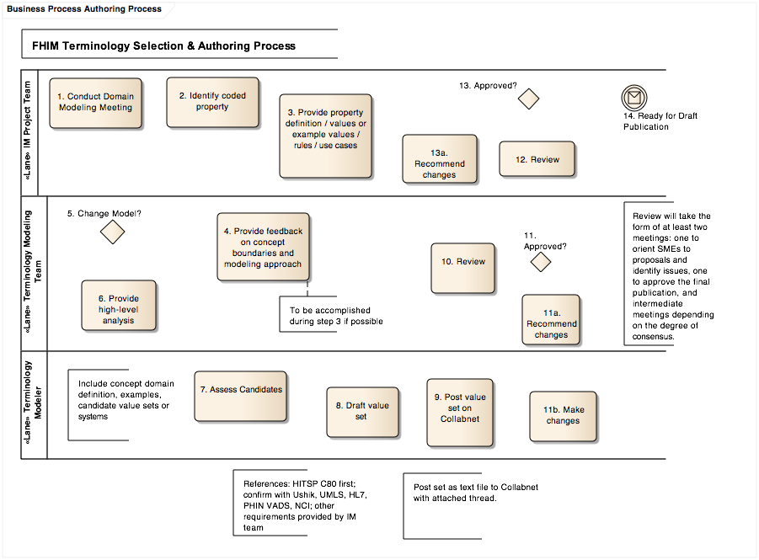

1. Conduct domain modeling meeting

The domain representatives & analysts conduct modeling sessions to determine and document the information requirements of federal partners in the domain.

1. Identify coded property

In certain cases, a property’s domain of values will require standardization, but will not be quantitative: in these cases, the property will be assigned a “coded” datatype.

1. Provide property definition, values or example values, rules, use cases

The domain representatives & analysts characterize the value domain for the property in order to inform the terminology modeling effort. This effort should draft as many as possible of the “definition” data elements in appendix B, as well as the binding properties listed above.

1. Provide feedback on concept boundaries and modeling approach

The terminology modeling co-leads review the requirements defined by the domain group in order to confirm that they are sufficiently detailed, and also to confirm that they model a single concept. In some cases, the terminology group will suggest changes to the model.

1. Change model

If a change is desired, the terminology group will communicate their recommendation to the domain modeling group.

1. Provide high-level analysis

If no change to the model is required, the terminology modeling co-leads will provide high-level analysis of the requirement—e.g., whether there may be existing candidate standards—to the terminology modeler.

1. Assess candidates

The terminology modeler will identify and assess existing candidates for the requirement. Assessment will include checking for conformance to FHIM terminology policies (documented below). Analysis will include comparison with resources available from standards repositories, including

* HITSP C-80 document
* PHIN VADS
* VSAC
* USHIK
* NCI (including CDISC)
* UMLS

Further, we will investigate the following domain-specific standards:

* HL7 V2 and V3
* Clinical data: SNOMED CT, LOINC
* Nursing: ICNP
* Demographics: US Census, ISO for countries & languages, FIPS, etc.
* Drugs: RxNorm

Note that CPT and ICD cover the same domains as SNOMED CT, and are not preferred systems.

1. Draft value set

Drafting the set may simply mean indicating that an existing standard is appropriate. In some cases, it may mean determining a new set of values. In many cases, it will mean taking an existing value set and making modifications.

1. Post value set

The terminology modeler will place the candidate value set on the CollabNet site, update the CollabNet task status, and make any necessary notes on the CollabNet discussion thread.

1. Review

At weekly meetings, the terminology modeler will propose value sets to the FHIM terminology modeling group. Members may preview the value sets—and their associated discussion threads—on CollabNet at their convenience.

1. Approve

The terminology modeling group determines whether the value set is ready for review by the domain group.

* 1. Recommend changes

If changes are needed, they are documented so that the terminology modeler has a clear understanding of required changes.

* 1. Make changes

After making requested changes, the terminology modeler posts the updated version on CollabNet for review at a subsequent meeting.

1. Review

The domain analysis team will review the terminology team’s proposed value sets for fitness.

1. Approve

If the value sets are satisfactory, the team will approve them for draft publication.

1. Recommend changes

If there are any issues, they will provide specific requirements back to the terminology team.

1. Ready for draft publication

At this point, the value sets are ready for publication in a value set repository that is readily accessible. The current repository is PHIN VADS but the NLM Value Set Authority Center (VSAC) is the eventual preferred location. FHIMS may reference value sets that exist in any number of repositories.

Publication

The following description addresses the process steps as illustrated in figure 2. Note that this process may change as operations transition from PHIN VADS to VSAC.

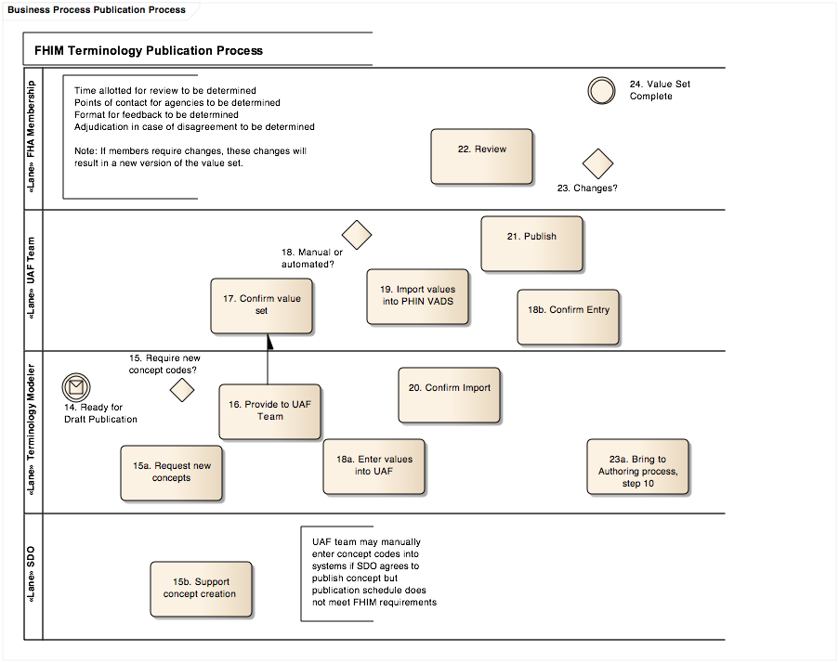

1. Require new concept codes

Most values will have been identified in an existing value set or code system, and can be so specified. Some value sets may contain values for which no appropriate standard exists.

1. Request new concepts

For these values, new concepts will be requested from the appropriate standards development organization. Clinical values will be modeled in an extension of SNOMED CT, and will be available for use quickly. Values required of other systems may take longer.

1. Support concept creation

This process will require a certain amount of support from the standards development organization.

1. Provide to UAF team

The terminology team will provide the value sets to the CDC’s PHIN VADS Universal Authoring Framework (UAF) team.

1. Confirm value set

The CDC will confirm that the value sets conform to CDC standards for value sets and that they do not conflict with or duplicate value sets already in PHIN VADS.

1. Manual or automated

Value sets may be entered into the UAF user interface or loaded via file.

1. Enter values into UAF

The terminology modeler creates the value set and enters the values into the UAF manually.

1. Confirm entry

The CDC ensures that entry was performed correctly.

1. Import values into PHIN VADS

Normally, The CDC will import value sets from the source files rather than re-typing them.

1. Confirm import

The terminology team will confirm that the import was performed correctly.

1. Publish

The value set is published via the UAF, and becomes visible in the public PHIN VADS application.

1. Review

The FHIM team invites all FHIM agencies to review the value set.

1. Changes

Some participating agencies may identify missing or incorrect concepts. They may at this point request changes of the FHIM Terminology Modeling team, using a provided change request template.

1. Bring to Authoring process, step 10

Change control (triage, confirmation of the issue, and validation of approach) will be handled by the terminology team in meeting, after which changes will be implemented following the authoring process.

1. Value set complete

Completeness is a relative concept, as change requests may come in at any time.

Consumption

The following description addresses the process steps as illustrated in figure 3.

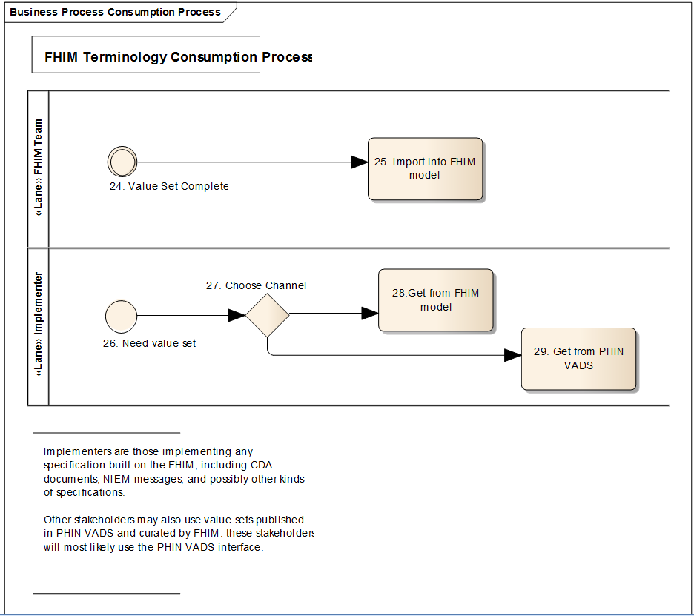

1. Import into FHIM model

When a value set is published, the FHIM information modeling team will import it into the Model-Driven Health Tools model. Any implementer using MDHT will be able to implement both classes and vocabularies from this resource.

1. Need value set

Implementers will reach points in the development process where they will need value sets.

1. Choose channel

The implementer will have two options for acquiring value sets.

1. Get from FHIM model

The value sets will be included in the MDHT repository, and will be available to implementers using Eclipse-based tools. Some sets will not be published here due to size restrictions.

1. Get from Repository

For large value sets, and for implementers who only want to constrain a single field or set of fields, it will be possible to acquire value sets ad hoc from a repository (PHIN VADS or VSAC), either manually or by web service.

1. Appendix A: Terminology Policies

The following continue to develop. They were captured on 11/19/2013 from the FHIM Wiki, at <https://www.projects.openhealthtools.org/sf/wiki/do/viewPage/projects.fhims/wiki/HomePage>.

1. FHIM values sets shall be implementable.
   1. Publication shall be extensional. Intensional definitions may be used for authoring.
   2. They shall be provided to implementers via an open and accessible interface.

This has been PHIN VADS (phinvads.cdc.gov/), but we plan to begin using VSAC (vsac.nlm.nih.gov) when it is available..

1. FHIM values sets shall follow standards where possible.
   1. The authors shall document preferred systems for domains, starting with HITSP C-80.
   2. Clinical concepts shall be taken from SNOMED CT, or a SNOMED CT extension.
      1. Where we modify an existing value set that does not use SCT, we will migrate the included contents into SCT.
2. FHIM values sets shall be versioned.
   1. Following PHIN VADS practice, a value set shall have a single OID, and versions shall have serial numbers.
      1. Proposed scheme: use the OID for dynamic assignment, and append the version number to the OID for static assignment. This may work internally, but it may not be consistent with CTS2.

This approach may not support other key platforms, and is subject to change.

1. FHIM may use externally defined value sets, but they will be managed as external value sets.
   1. Sets maintained by other organizations may meet our requirements. We may choose to bind to these value sets statically, in order to avoid uncontrolled change, or dynamically, in order to leave the burden of maintenance to the external group.
   2. Externally maintained sets that partially meet our requirements may be leveraged in the authoring process, but the resulting set is a FHIM value set. No linkage to its source is required, except as a historical record of the authoring process.
2. Dates
   1. We go beyond the HITSP recommendation and adopt the ISO 8061 specification, recording dates as text strings of the form "YYYY-MM-DDThhmmss,ff” (see <http://en.wikipedia.org/wiki/ISO_8601> for more information).
3. Completeness
   1. Some value sets may not be complete. These will be useful as examples, or as “starter sets.” They will be clearly identified.
4. Relationships
   1. Properties may require different subsets of the value domain in different use cases. If there are no structural differences in a property in the different cases, the information model will represent a single property, which will have a single value set. This value set will contain values for all contexts or use cases.
      1. There may be cases (e.g., microbiology labs requiring "microorganisms" not "species") where a new class is desirable despite a lack of structural difference.
      2. For supersets, subsequent modeling efforts (e.g., messaging guides) may further constrain these value sets.
      3. We will investigate the possibility of subsetting value sets in an MDHT formalism that recognizes context or use.
   2. Other relationships (other than subsets) are delegated to the source system.
5. Stewardship
   1. As steward, FHIM will prepend PHIN VADS “codes” for value sets with “FHA,” for “Federal Health Architecture.”
   2. FHIM value sets will be given OIDs from the FHA root.
6. Backward compatibility
   1. Backward compatibility is a valuable property, but the FHIM is modeling the future state, and will not be constrained to current patterns where those patterns don’t meet requirements.
   2. Where backward compatibility can be achieved without compromising other design principles, it will be supported.
7. Mixing systems
   1. A value set shall draw concepts from a single code system.
   2. In cases where values from different systems are required in different use cases, a “grouping” value set will include value sets constructed from the respective systems. Use cases may constrain the binding to a specific member value set.
8. Null values
   1. Null values are values from the Null values system, and will not be included as proper values in FHIM value sets.
   2. "Nullable" is a property of the information model, to be captured during IM analysis.

Whether null flavor values are part of a coded datatype or represent another element—and therefore whether the TM group is responsible for defining allowable values—is TBD

1. New values
   1. FHIMS will use an FHA Extension of SNOMED CT as the preferred venue for publishing new clinical concept codes, where the domain is appropriate. [Probably via NLM, not a FHIM-managed extension]
2. Status
   1. Unless otherwise indicated, status shall follow the HL7 V3 state machine. Refinements may be supported in a domain-appropriate status modifier.
3. Extensibility
   1. Extensibility is a model binding property, not a value set property.
   2. We prefer to model the value sets broadly, and have implementers map to the standards, than to allow locally defined codes.
4. Value set names
   1. Value set names shall represent the semantics of their content. Names of applications or programs will only be used when the rationale for selection is unknown.
   2. When a FHIM value set is based on another value set, the existing name will be preserved if it doesn’t break other policies
5. Appendix B: Value Set Data Elements

These elements are captured for each value set defined. Not all are required, and sets that have not been published may not have values in several fields relating to the publication process. Publication is limited to those elements supported by the publication platform (PHIN VADS or VSAC). Equivalent elements from the Model Driven Health Tools (MDHT) platform, CDC PHIN VADS site, HITSP C-80 document, and CTS2 specification are listed.

| **Group** | **Property** | **Definition** | **MDHT** | **PHIN VADS** | **HITSP** | **CTS2** |
| --- | --- | --- | --- | --- | --- | --- |
| Definition | valueSetDefinition | text definition of value set semantics | definition | description | Definition | ValueSetCatalogEntry.resourceSynopsis |
| Definition | valueSetExamples | a set of 3-5 example values to illustrate the description |  |  |  |  |
| Definition | valueSetIntensionalDefinition | formal intensional definition of set |  |  |  | ValueSetDefinitionEntry |
| Definition | valueSetType | Intensional, enumerated or grouping | type |  | Type |  |
| Definition | valueSetView | guides or domains for publication |  | views |  |  |
| Identification | valueSetId | OID for value set |  |  | Identifier | ValueSetCatalogEntry.about |
| Identification | valueSetName | human-readable name of value set | fullName | Name | Name | ValueSetCatalogEntry.valueSetName |
| Identification | valueSetVersionNumber | serial integer to append to value set OID | version | version | Version | ValueSetDefinition.documentURI |
| Publication | valueSetFileUrl | URL for value set in PHIN VADS |  |  | URL |  |
| Publication | valueSetVersionEffectiveDate | version effective date (YYYYMMDD) | effectiveDate | version effective date | Effective Date | ValueSetDefinition.officialActivationDate |
| Publication | valueSetVersionExpirationDate | version expiration date (YYYYMMDD) | expirationDate | version expiration date | Expiration Date |  |
| Source | sourceValueSetComment | explanation of FHIM divergence from source set |  |  |  |  |
| Source | sourceValueSetName | name of the value set on which the FHIM set is based |  |  |  |  |
| Source | sourceValueSetOID | OID of the value set on which the FHIM set is based |  |  |  |  |
| Source | sourceValueSetVersion | version of the value set on which the FHIM set is based |  |  |  |  |
| Source | valueSetDefaultSystemName | name of default system for value set | codeSystem |  | Code System Name |  |
| Source | valueSetDefaultSystemOID | OID of default system for value set | codeSystem |  |  |  |
| Source | valueSetAssigningAuthority | text name of authority defining value set | source |  | Source |  |
| Usage | valueSetGroup | [multiple] tag for grouping (by domain, use, organization) |  | PHIN vocabulary groups | Purpose |  |
| Usage | valueSetLicenseRequirements | text license requirements for value set |  |  |  |  |
| Usage | valueSetUsageNotes | special cases or conditions of use |  |  |  |  |
| Usage | valueSetVersionCompleteness | "complete" or "incomplete" |  |  |  |  |
| Workflow | valueSetVersionProcessingStatus | status for purpose of FHIMS: in process, FHIM review, SME review, CDC review, published, withdrawn | status |  |  |  |
| Workflow | valueSetVersionProcessingStatusDate | date on which status is assigned | statusDate |  |  |  |
| Workflow | valueSetVersionPublicationComments | note to accompany release |  | version description |  |  |
| Workflow | valueSetVersionPublicationDate | version publication date (YYYYMMDD) | revisionDate |  | Revision Date | ValueSetDefinition.officialReleaseDate |
| Workflow | valueSetVersionPublicationStatus | status as published in PHIN VADS: proposed, published, retired |  | version status | Status | ValueSetCatalogEntry.status |
| Workflow | valueSetVersionPublicationStatusDate | date on which status is assigned |  | version status date |  | ChangeDescription.changeDate |

Note: Three HITSP-defined properties are not included.

* Binding: this is independent from the value set, as one value set may be bound to multiple model elements.
* Creation Date: we have effective and publication dates, and internally we have status dates. “Creation” was not an event of interest.
* Code System Source: meaning unclear.